Cinder Cycle
Propulsion-Integrated Waste Reclamation System
Document Type | Proof-of-Concept White Paper
Concept Thesis | Use propulsion-adjacent heat, plasma exposure, and ionization to sterilize waste, reduce density, and reclaim useful material streams.
Primary Integration | Waste disposal + life support + Eden agriculture + cooling loops
Status | Speculative integrated subsystem architecture
Abstract
Cinder Cycle is a propulsion-adjacent waste reclamation concept for closed-loop spacecraft and sealed habitats. Instead of treating waste management as a standalone burden, the system uses reactor waste heat, controlled plasma exposure, and ionization-based fractionation to sterilize refuse, reduce material density, and recover usable water, nutrient matter, gas fractions, and inert solids. The goal is not to feed raw trash directly into a propulsion chamber, but to route waste through a staged processing architecture that converts disposal load into recoverable support mass for agricultural, cooling, and environmental systems.
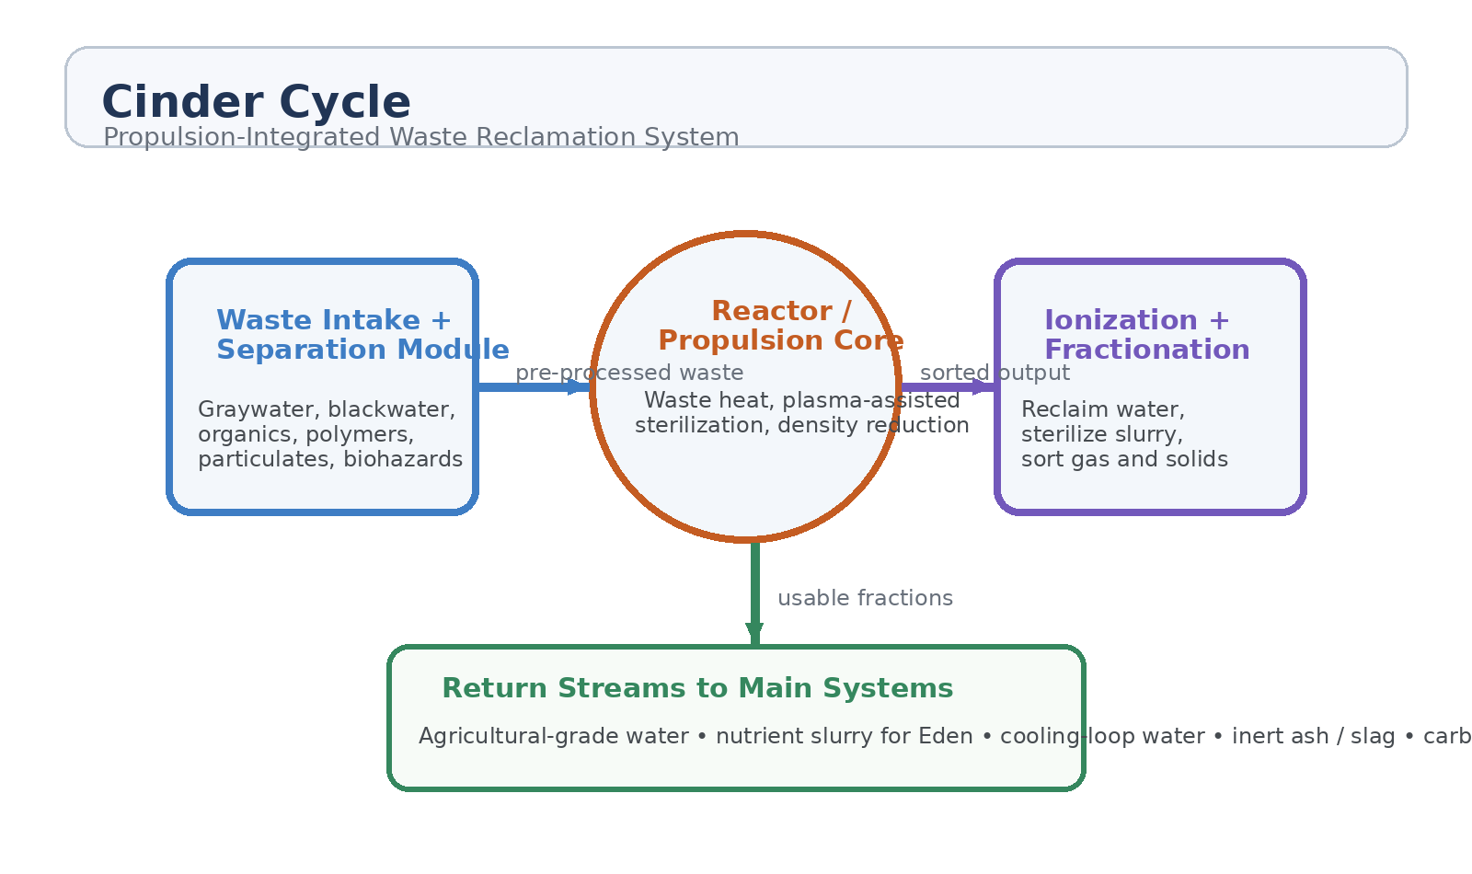
Figure 1. Conceptual Cinder Cycle architecture: waste intake, propulsion-adjacent processing, and return streams.
1. Concept Thesis
Deep-space vessels do not merely have an energy problem. They also have a mass, contamination, and volume problem. Waste accumulates, pathogens multiply, water quality degrades, and storage becomes a liability. Cinder Cycle proposes that one of the ship’s most difficult burdens can be turned into a systems advantage by using propulsion-adjacent heat and field infrastructure to process waste into reusable fractions.
The design philosophy is simple: propulsion does not consume waste as primary fuel. Instead, propulsion-side energy processes the waste. That distinction keeps the architecture coherent, safer, and easier to integrate with life support and agriculture.
2. Core System Architecture
Layer | Subsystem | Primary Function | Output
L1 | Waste Intake + Separation | Splits graywater, blackwater, organics, solids, polymers, particulates, and biohazards into processable streams. | Sorted feed
L2 | Thermal / Plasma Sterilization | Uses controlled waste heat and plasma exposure to sterilize, crack, and reduce material density. | Reduced sterile mass
L3 | Ionization + Fractionation | Separates reclaimed water, gas fractions, nutrient slurry, and inert ash or slag. | Usable fractions
L4 | Return Stream Routing | Routes recovered material to Eden, cooling loops, industrial wash, or further purification. | Closed-loop reuse

2.1 Waste Intake and Separation
The first stage is a disciplined intake module, not a dumping chute. Incoming material is sorted into distinct streams such as graywater, blackwater, organics, polymers, particulates, metals, and hazardous biological waste. This matters because spacecraft reclamation fails when every material class is treated identically. The intake module is the ship’s matter triage layer.
• Graywater can be reclaimed faster and at lower risk than mixed blackwater.
• Organic sludge can be sterilized and reconditioned into agricultural feedstock.
• Polymers and inert solids can be reduced, isolated, or stored as industrial residue.
• Biohazards require complete sterilization before reintegration into any support loop.
2.2 Thermal and Plasma Processing
Cinder Cycle uses propulsion-adjacent heat rather than wasting it. Controlled thermal exposure and plasma-assisted sterilization reduce biological load, shrink waste density, and crack complex material into simpler fractions. The system therefore doubles as both a contamination-control layer and a volume-reduction layer. It should be positioned near energy-rich compartments, but behind hard isolation boundaries so life-support water and crew spaces never directly touch the raw process chamber.
2.3 Ionization and Fractionation
After sterilization and reduction, ionization-based filtering and fractionation separate useful material streams. Recovered water is graded by quality. Gas fractions can be routed into carbon handling or vent-control logic. Nutrient-rich organics can be conditioned for Eden or other agricultural systems. What remains becomes inert ash, sterile slag, or controlled industrial residue.
3. Return Streams and System Reuse
The real power of Cinder Cycle is not waste destruction. It is controlled return. The system creates a set of recovered material classes that can re-enter ship operations without pretending that every output is fit for human consumption.
Recovered Stream | Best Use | Notes
High-grade recovered water | Further purification or technical reserve | Can become crew-use water only after final polishing and verification.
Agricultural-grade water | Crop runoff, filtration beds, Eden loops | Useful even if not potable.
Nutrient slurry / organic char | Soil substitute, nutrient refeed, bio-reactor support | Must remain sterile and composition-verified.
Gas fractions | Carbon routing, chemistry support, controlled venting | Should never be assumed safe without composition sensing.
Inert ash / slag | Storage, shielding filler, industrial residue | Potential structural or ballast use if chemically stable.

4. Why Propulsion Integration Helps
• Waste heat already exists and must be managed; using part of it for sterilization and reduction improves systems efficiency.
• Plasma-adjacent processing offers strong pathogen kill capability and can break down stubborn organic matter.
• Volume reduction lowers storage burden and extends mission endurance.
• Closed-loop recovery reduces demand on fresh water and agricultural inputs.
• The same architecture that handles contamination can also support resilience during emergency life-support degradation.
5. Safety Boundaries
Cinder Cycle only works if the boundaries are brutally clear. The system should not blur reactor integrity, crew water, and raw waste into one romantic pipe dream. It requires hard segregation, verified sensors, and quality grading before any stream returns to main support loops.
• Primary reactor chamber must remain isolated from waste intake hardware.
• Crew potable water must be downstream of additional purification and continuous validation.
• Agricultural return streams need their own quality thresholds distinct from human consumption thresholds.
• Biohazard waste must pass sterilization confirmation before entering any downstream fractionation stage.
• Emergency bypass storage is required if the reclamation chain is offline.
6. Proof-of-Concept Build Path
Phase | Goal | Bench Activity | Success Signal
P1 | Separation discipline | Build a waste intake rig that cleanly separates graywater, blackwater, organics, and solids into distinct process streams. | Reliable stream isolation
P2 | Sterilization test | Use controlled heat and plasma-analog exposure to sterilize and reduce representative waste mixtures. | Measured pathogen reduction and volume shrinkage
P3 | Fractionation test | Recover water, gas, and solid fractions after processing and grade them by quality. | Repeatable reclaimed outputs
P4 | Agricultural reuse | Feed reclaimed agricultural-grade water and nutrient fractions into crop filtration or Eden-like test beds. | No contamination spread and stable growth support
P5 | Integrated endurance loop | Run a closed-loop demo with waste intake, thermal processing, fractionation, and return routing over multiple cycles. | Stable operation with audited material balances

7. Measurements
• Mass reduction ratio after sterilization and thermal/plasma treatment.
• Recovered water volume by quality grade.
• Pathogen kill verification across representative waste classes.
• Nutrient retention in agricultural return fractions.
• Energy overhead per kilogram processed.
• Cross-contamination rates between raw and reclaimed streams.
• System stability during repeated intake-and-return cycles.
8. Integration Opportunities
Cinder Cycle fits naturally beside Eden, thermal-management architecture, and propulsion-side infrastructure. It can become the waste-handling spine for a baseline vessel, a station support module, or a larger agricultural ship. In all three cases, the system turns disposal from a dead-end utility into an active part of ship metabolism.
• Eden integration for nutrient and crop-loop water reuse.
• Thermal architecture integration for waste-heat scavenging.
• Emergency sanitation mode during outbreak or contamination events.
• Industrial support mode for machine shops, hydroponics, and non-potable wash loops.
9. Conclusion
Cinder Cycle is one of the cleaner GhostCore integrations because it uses what the ship already struggles with: waste mass, waste heat, contamination, and finite water. By routing refuse through staged separation, plasma-assisted sterilization, and ionization-based fractionation, the vessel can reclaim useful material streams without pretending that raw waste magically becomes thrust or drinking water.
The result is a realistic closed-loop philosophy: burn what must be burned, sterilize what must be sterilized, reclaim what can be reclaimed, and return only what has earned its way back into the system.
Working one-line doctrine: Use propulsion-side energy to process waste into survivable matter streams, not to pretend trash is magic fuel.

